RTX Corporation (RTX) Visual Equity Report
Readable visual equity report core with larger fonts, darker text, and improved contrast defaults.

1. Executive Summary
- RTX closed at $174.26 on 2026-04-24.
- The stock is below the 200-day moving average ($178.08), with 20-day and 50-day moving averages at $193.88 and $199.09.
- Analyst consensus target is $215.06 with 22 analysts and rating 2.1 - Buy.
- This reusable generator handles the market, analyst, valuation, and historical visual core. Company-specific earnings and segment panels can be layered in when curated inputs are available.

2. Visual Snapshot
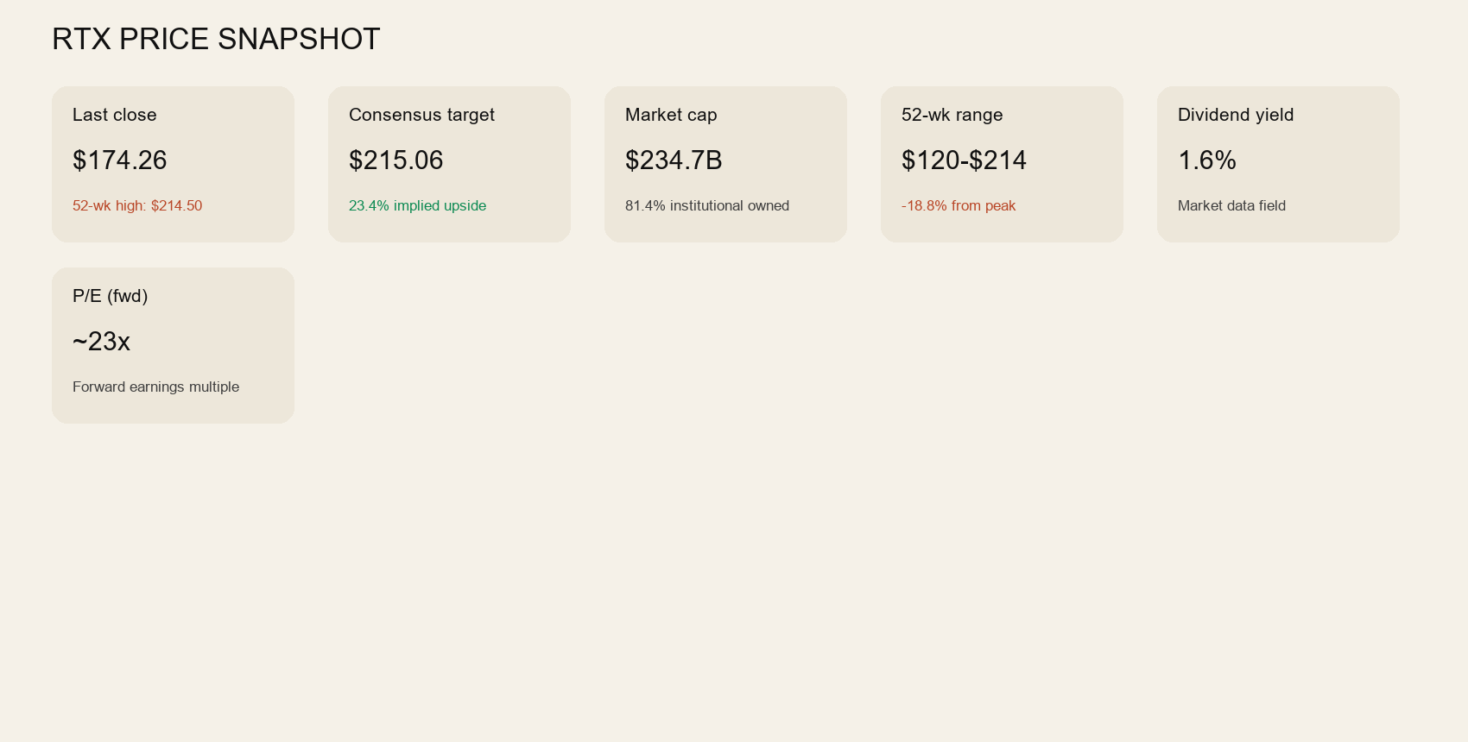

3. Historical Trend
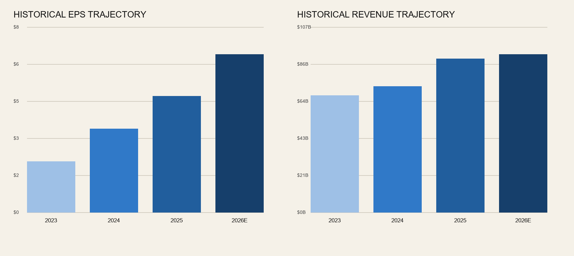

4. Valuation and Quality Metrics
Metric | Value
Market cap | $234.7B
Enterprise value | $268.5B
Revenue | $90.4B
Free cash flow | $7.2B
Trailing P/E | 32.7
Forward P/E | 23.1
Dividend yield | 1.6%
Profit margin | 8.0%
Operating margin | 13.2%
ROE | 11.6%
Current ratio | 1.02
Quick ratio | 0.65

5. Analyst Context
Metric | Value
Consensus target | $215.06
Median target | $222.50
Target range | $179.00 to $242.00
Rating | 2.1 - Buy
Recommendation | Buy
Analyst count | 22

